**GIT Branching**

**Objective**: Commit HTML, CSS & JavaScript assignments into GIT.

SECTION-2 - (CSS assignments) Steps to follow:

1. Create a new branch ‘css-assignment’.

**Command used to create a Branch:**

git branch css-assignment

**Output:**

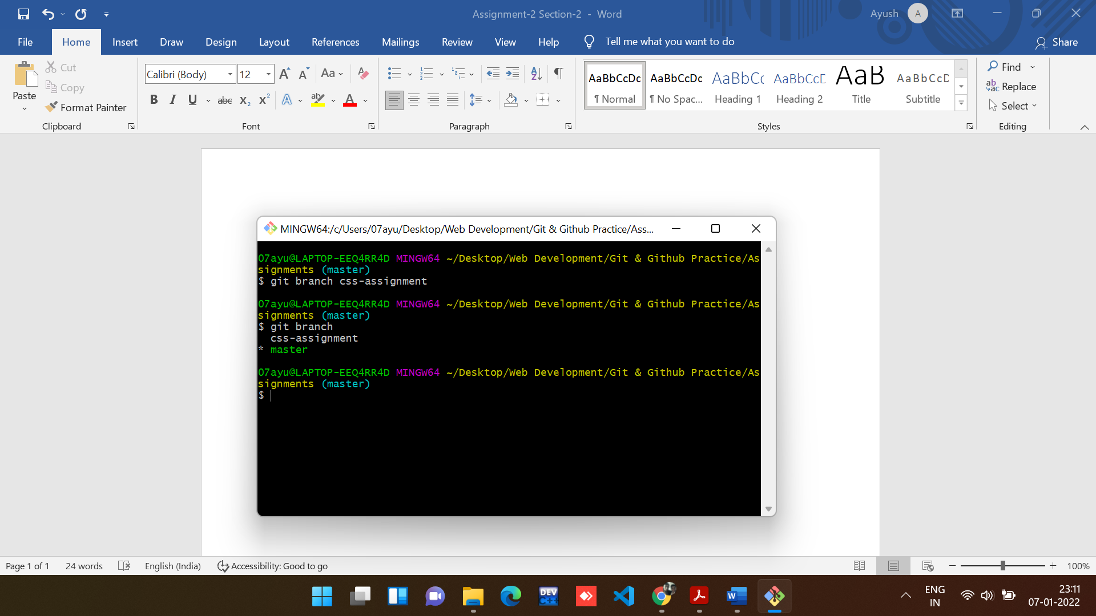

Note: git branch is a command to see all the branches.

1. Switch to ‘css-assignment’ branch.

**Command used to switch Branch:**

git checkout css-assignment

**Output:**

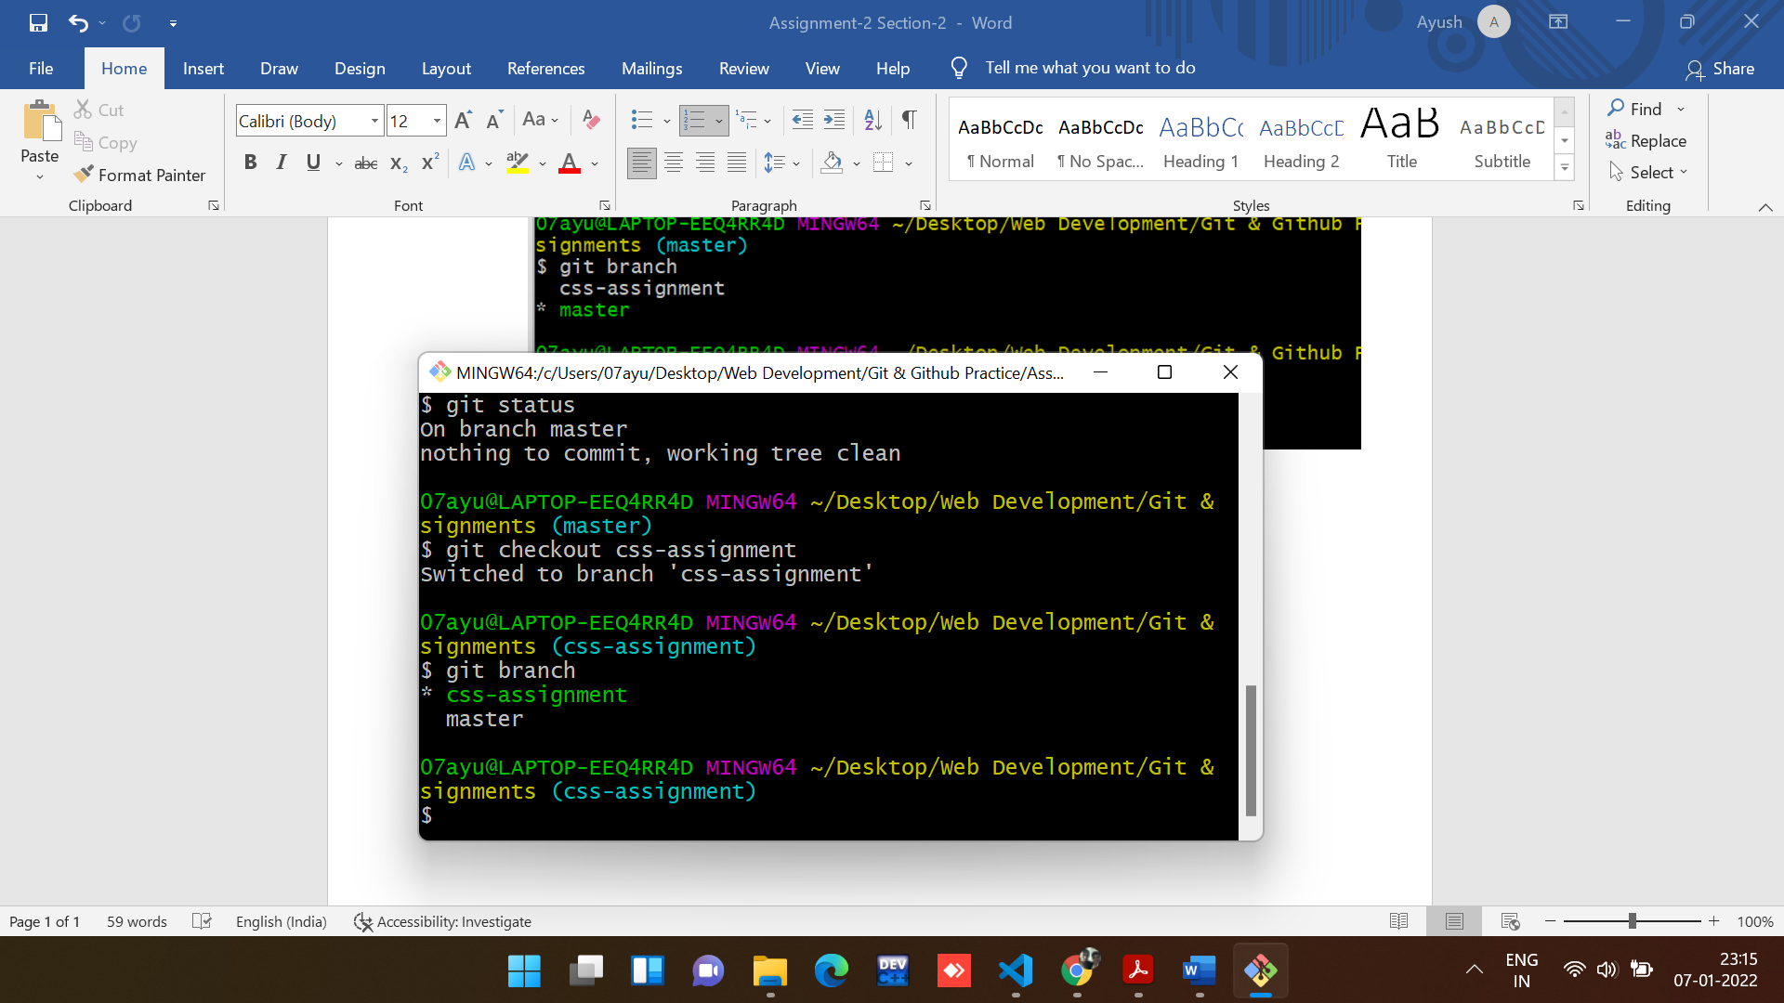

1. Copy all CSS assignments inside ‘Assignments’ folder.

Copied all the CSS files in the Assignment folder

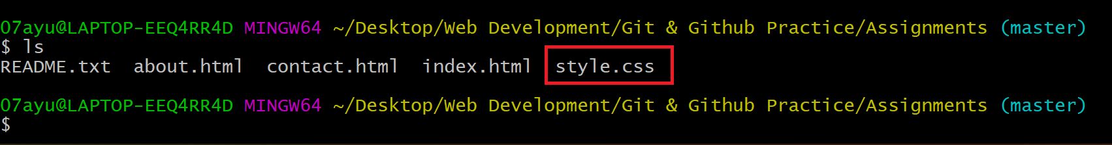

1. Commit CSS assignments into ‘css-assignments’ branch.

**Command to commit all the changes:**

git add -A

git commit -m “description”

**Output:**

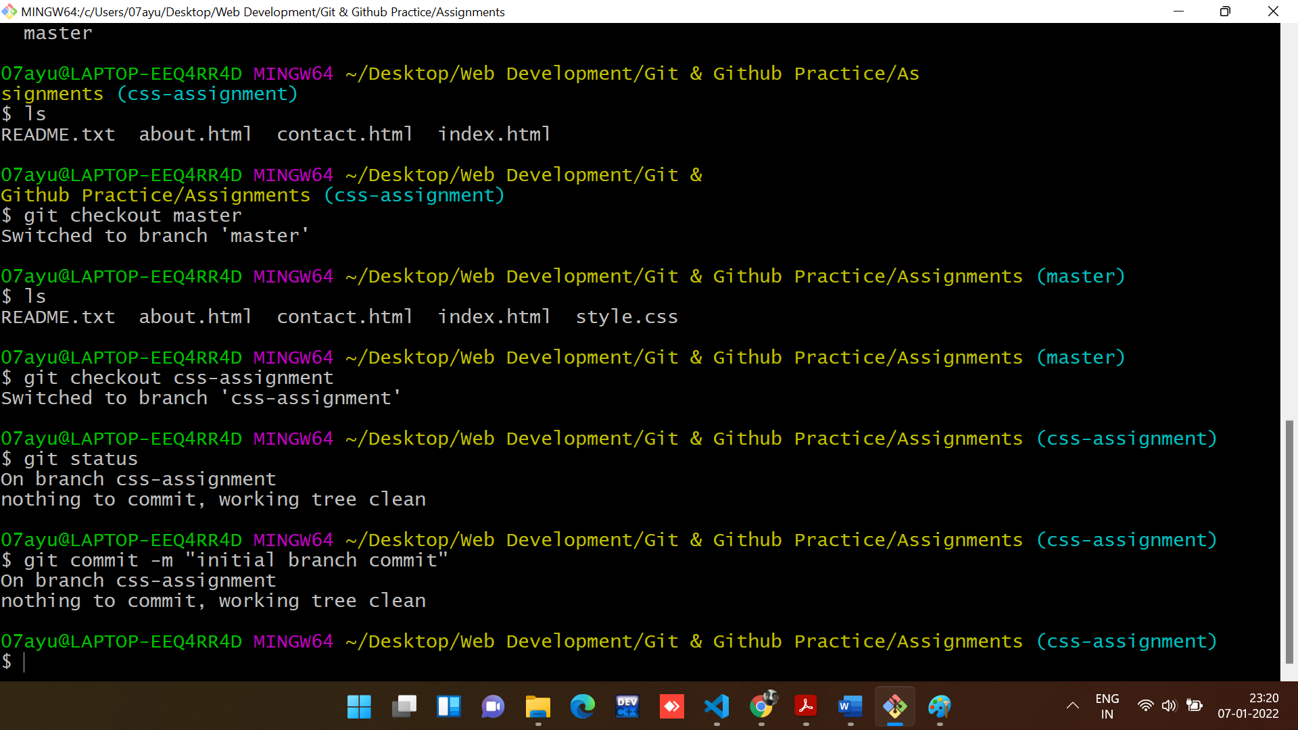

1. Make minor changes into README.txt file on line 1 belonging to ‘css-assignments’ branch.

**Changes made in README.txt in css-assignment branch.**

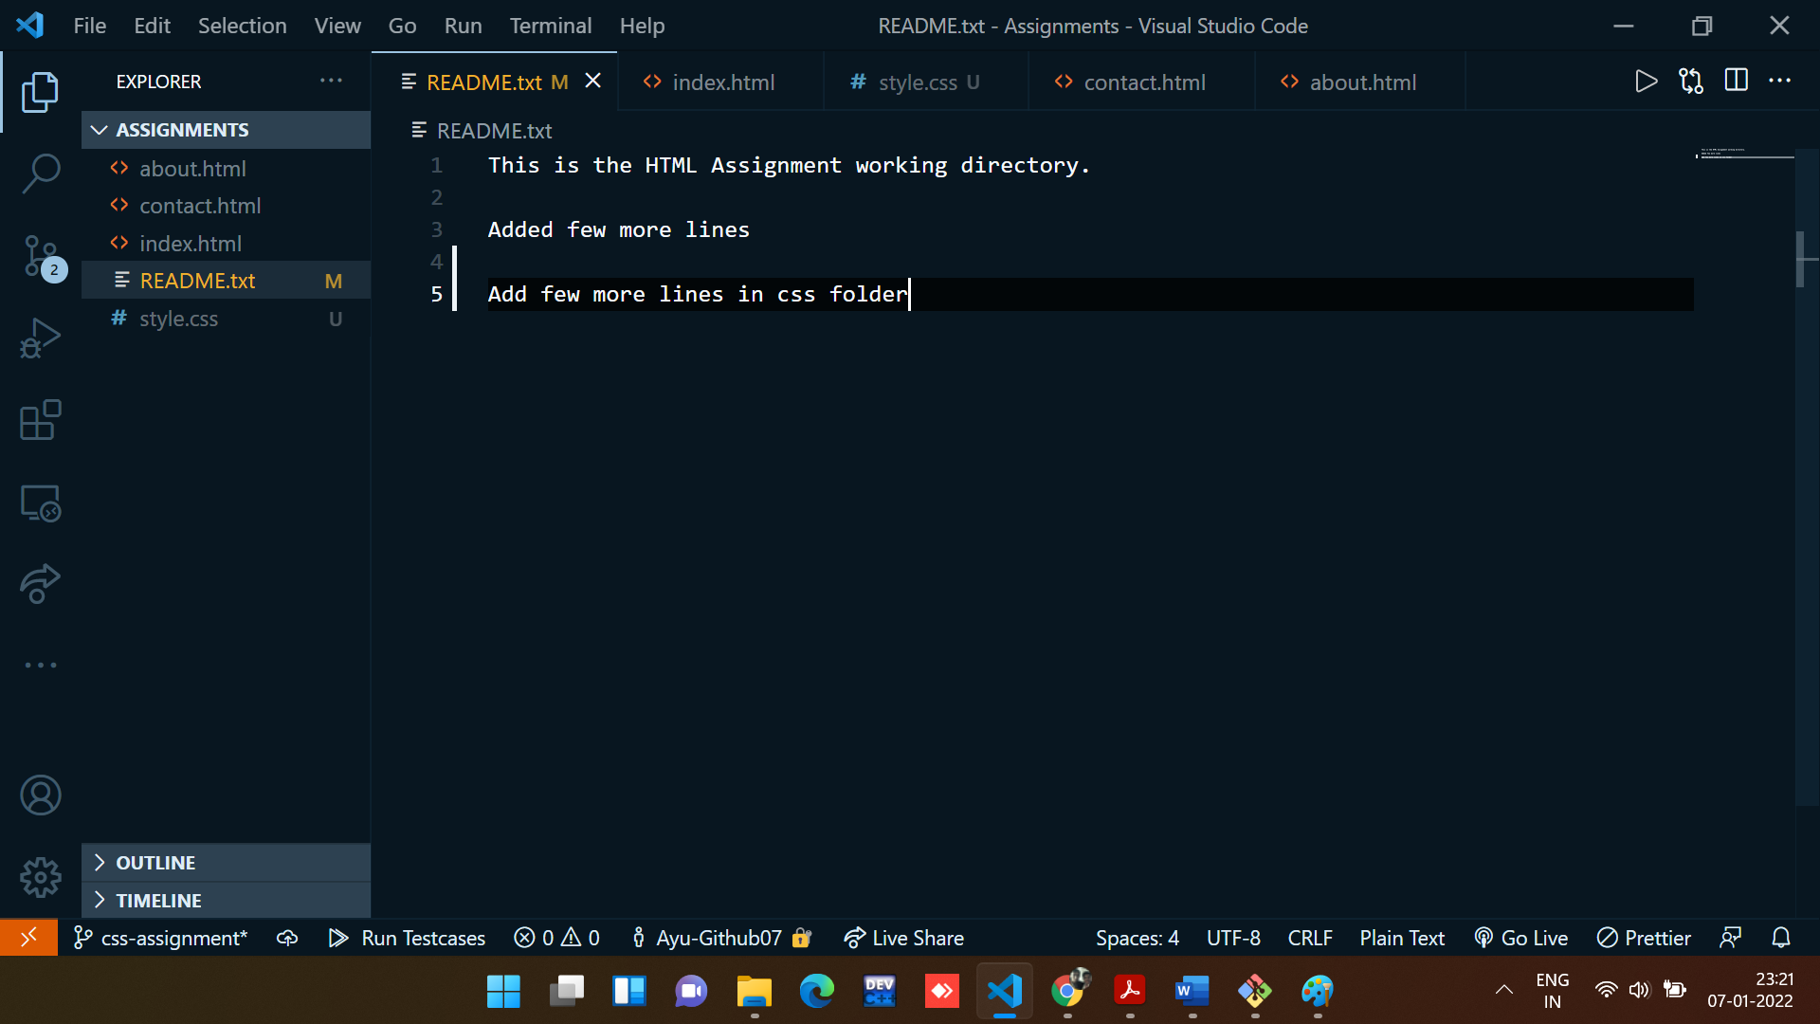

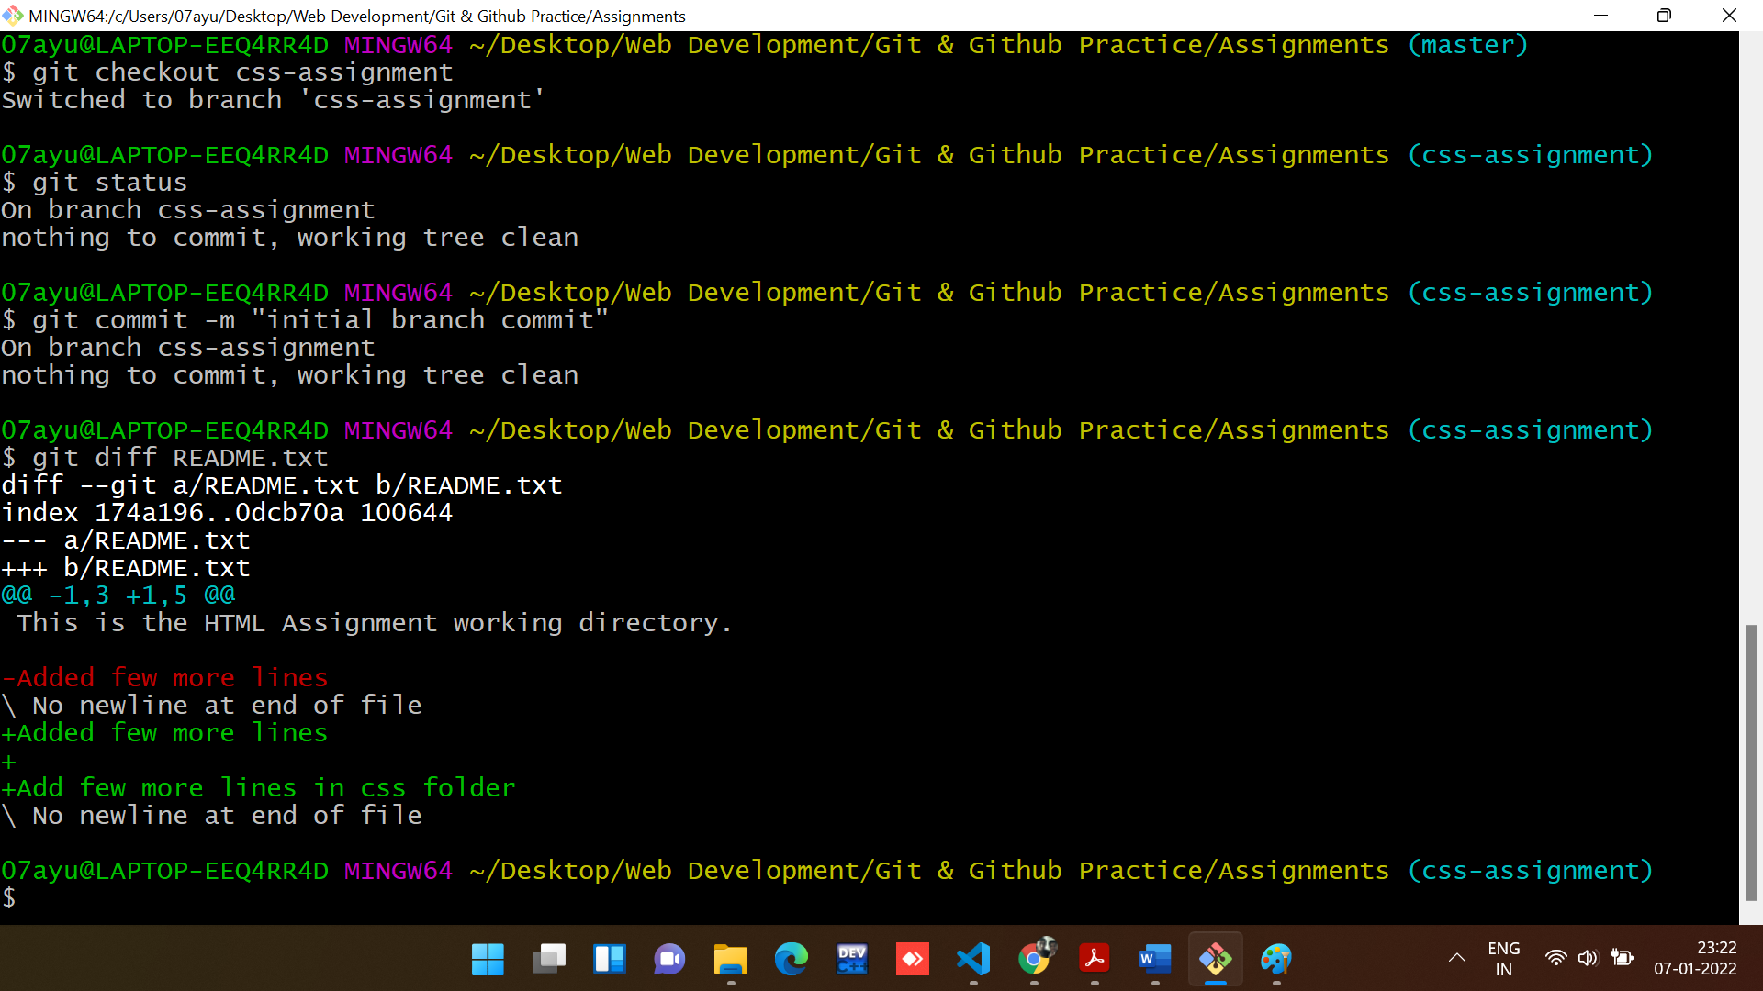

1. Commit those changed files.

**Command to commit all the changes:**

git add -A

git commit -m “description”

**Output:**

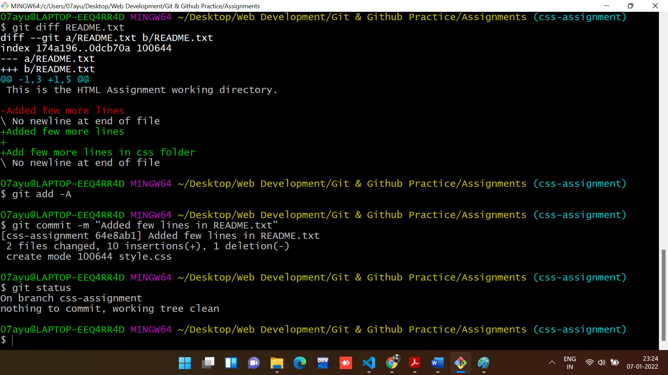

1. Switch to master branch.

**Command used to switch Branch:**

git checkout master

**Output:**

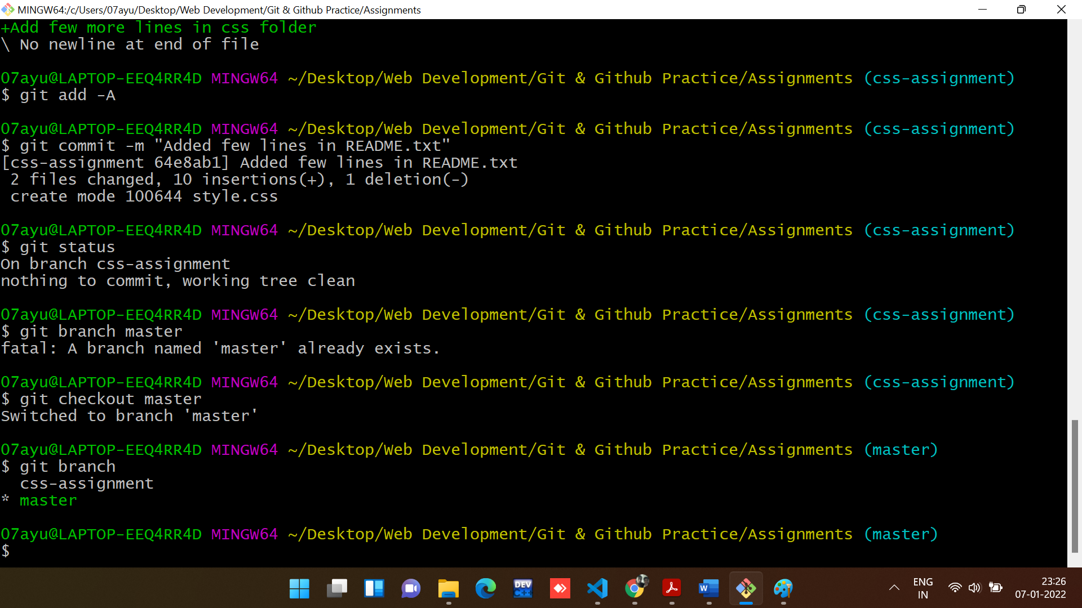

1. Make minor changes into README.txt file on line 3 & commit those changes into master.

**Changes made in README.txt in master branch.**

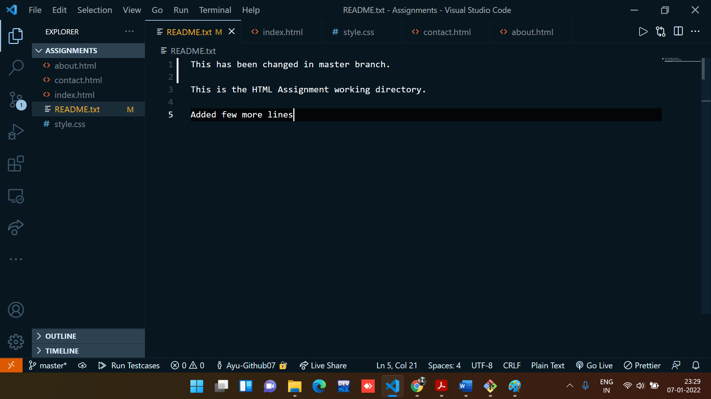

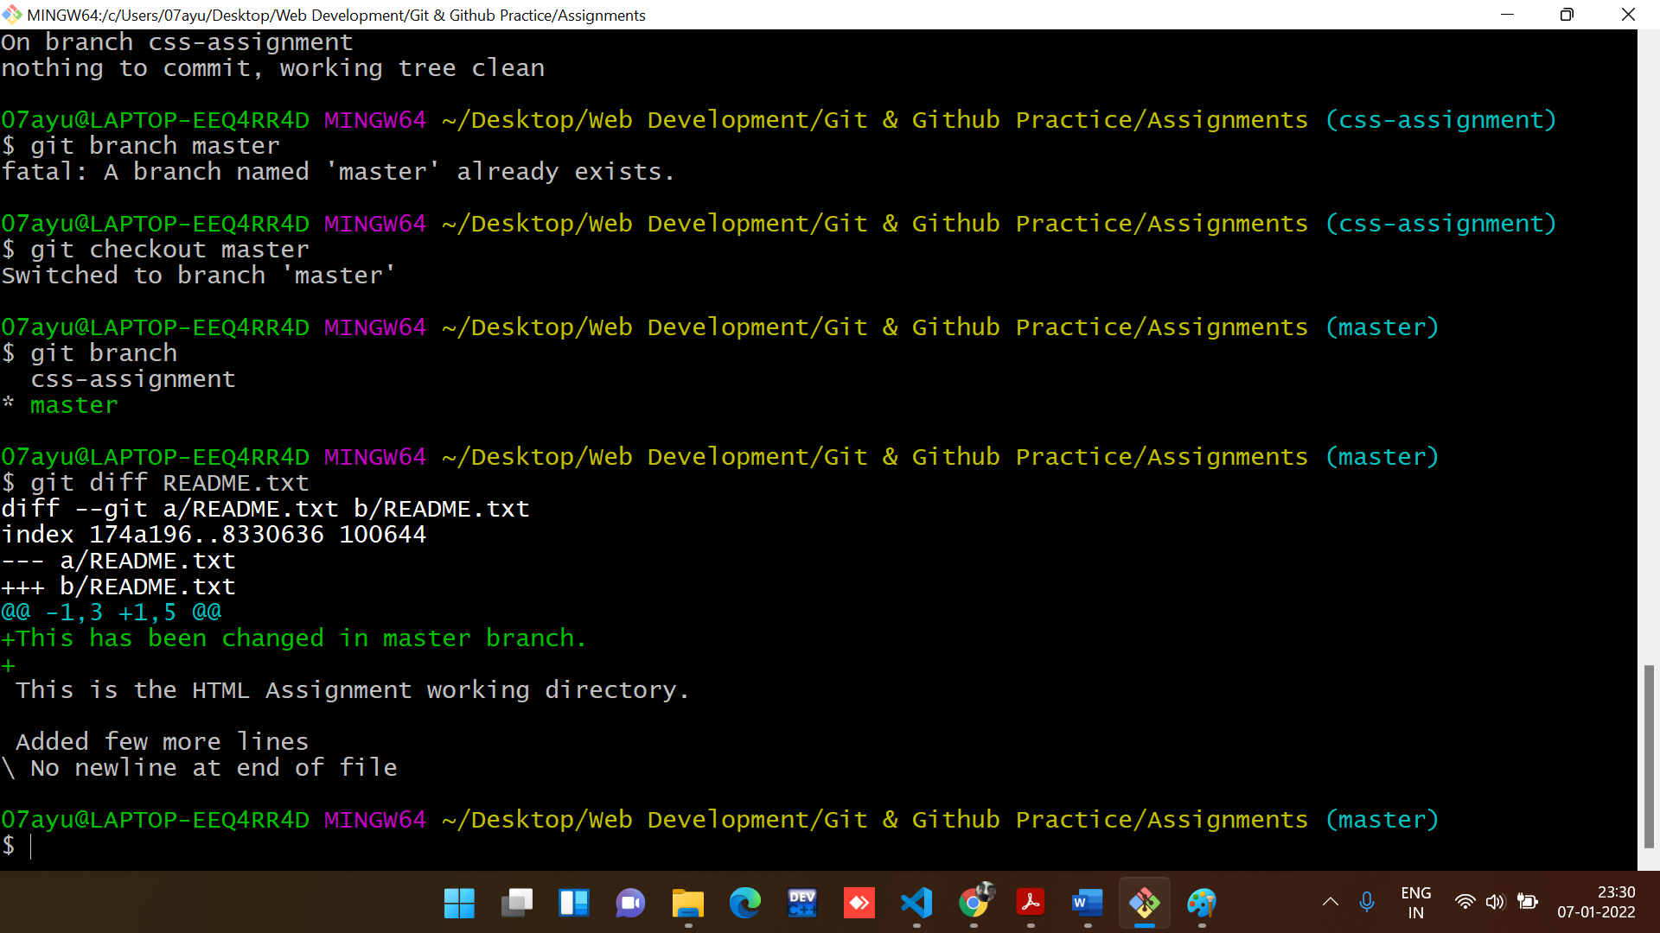

Changes committed:

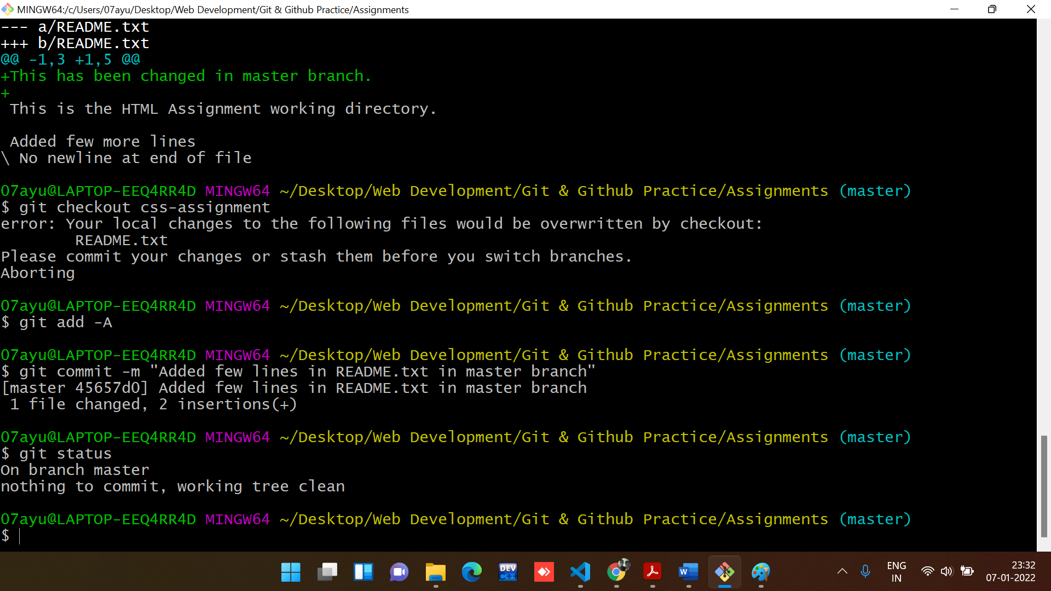

1. Again switch to ‘css-assignments’ branch.

**Command used to switch Branch:**

git checkout css-assignment

**Output:**

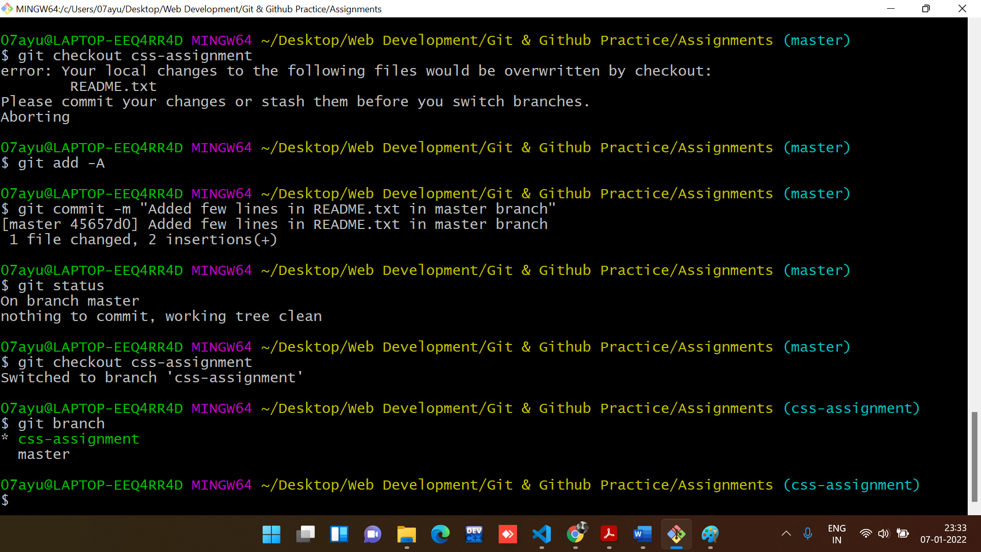

1. Make minor changes into few files belonging to ‘css-assignments’ branch.

Changes has been made in style.css

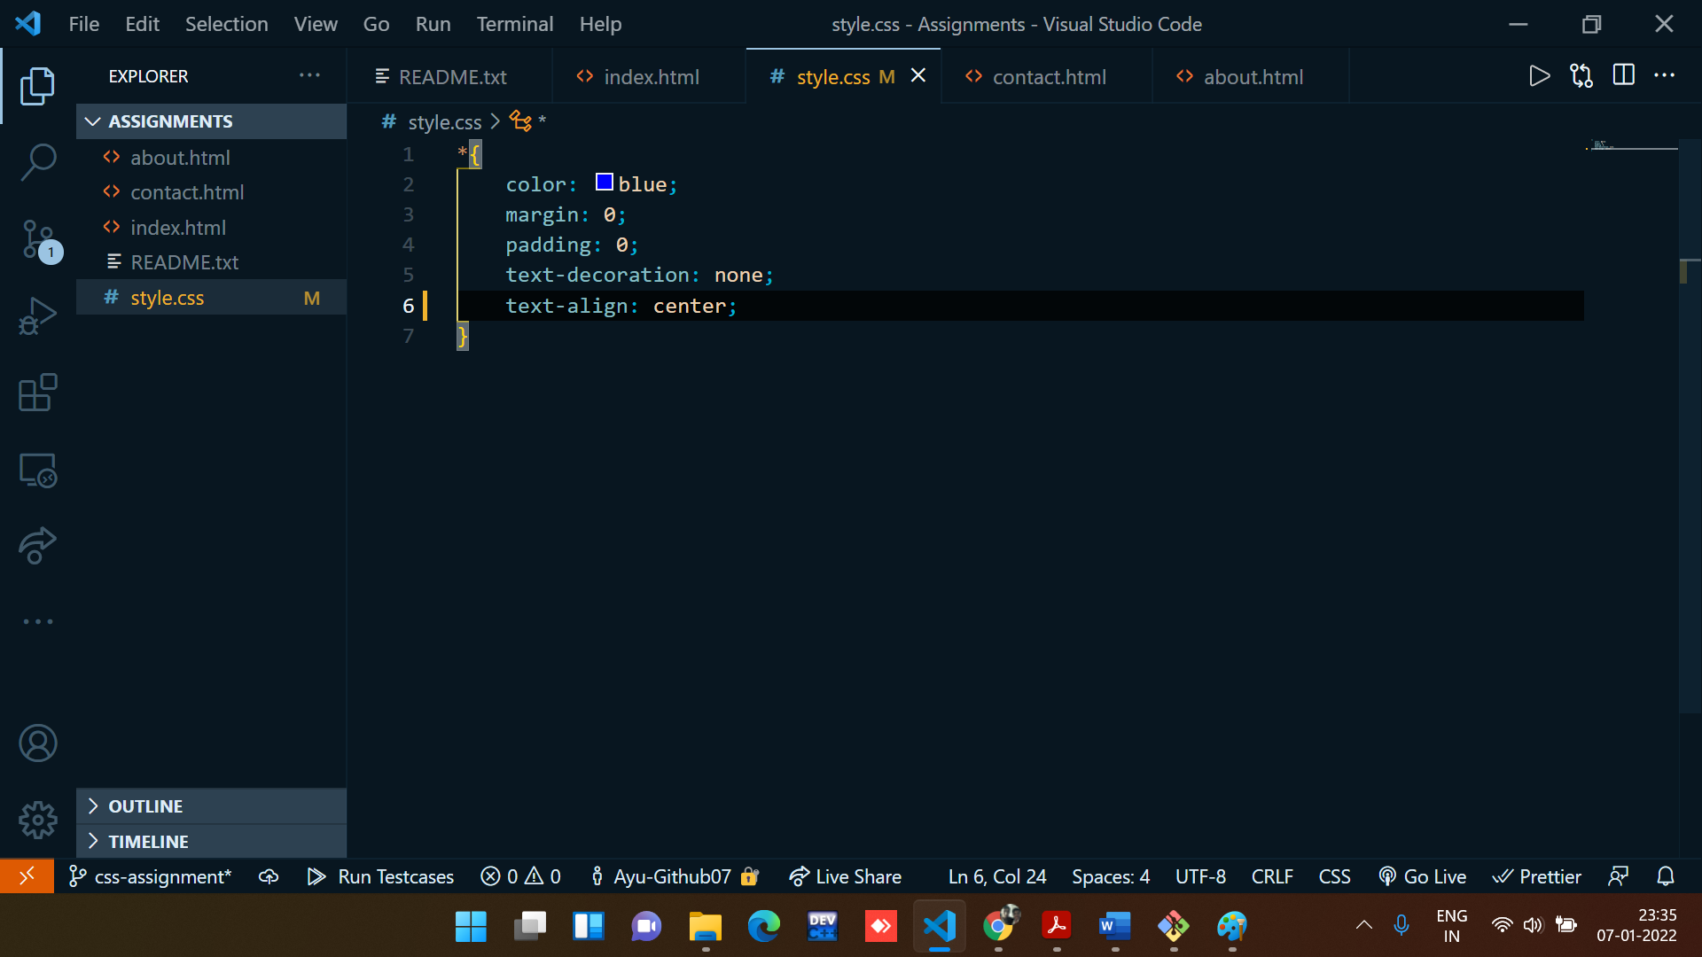

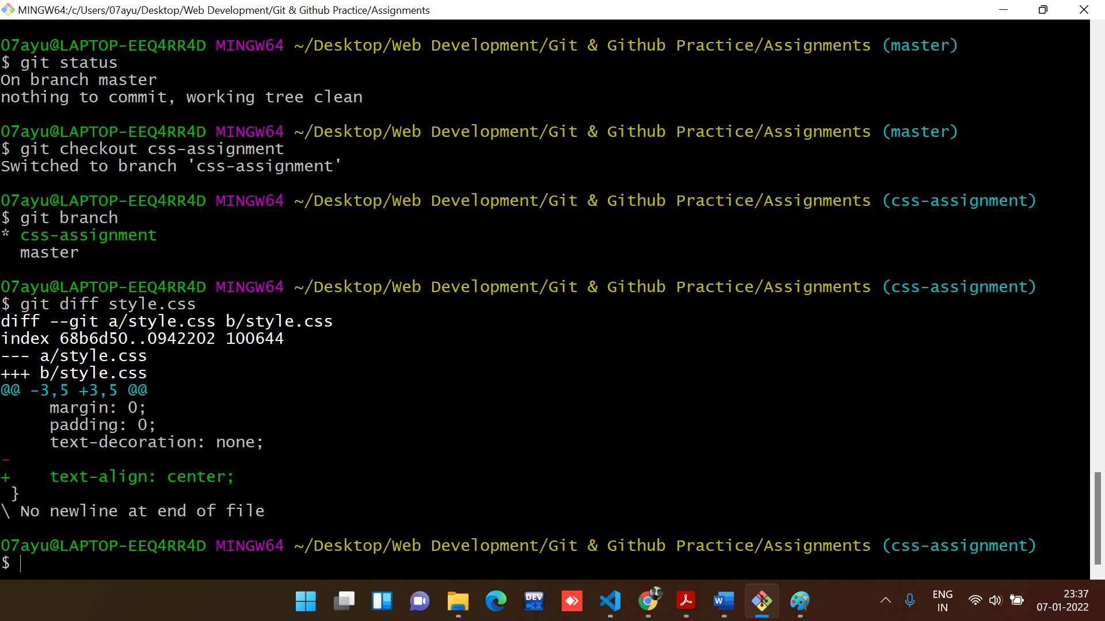

1. Commit those changes.

**Command to commit all the changes:**

git add -A

git commit -m “description”

**Output:**

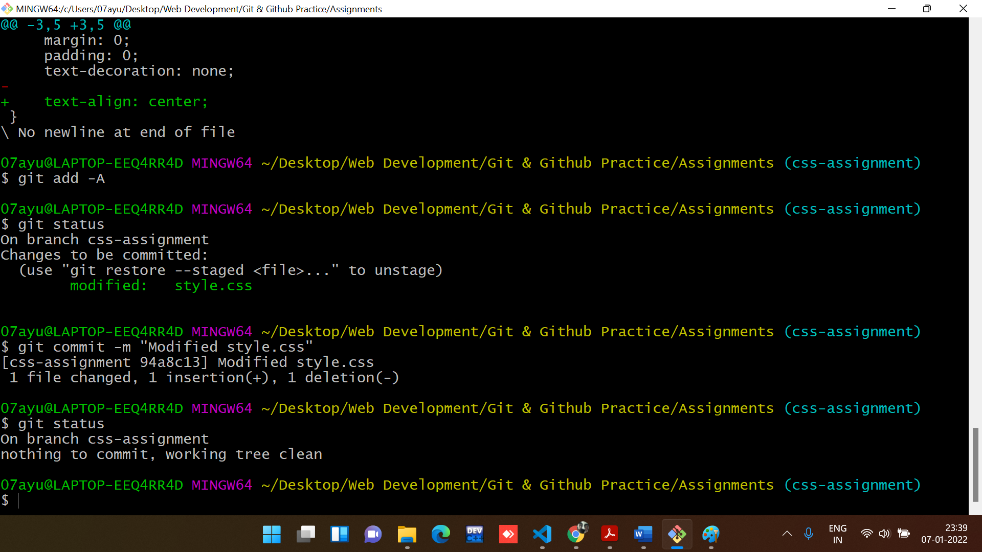

1. Switch to master.

**Command used to switch Branch:**

git checkout master

**Output:**

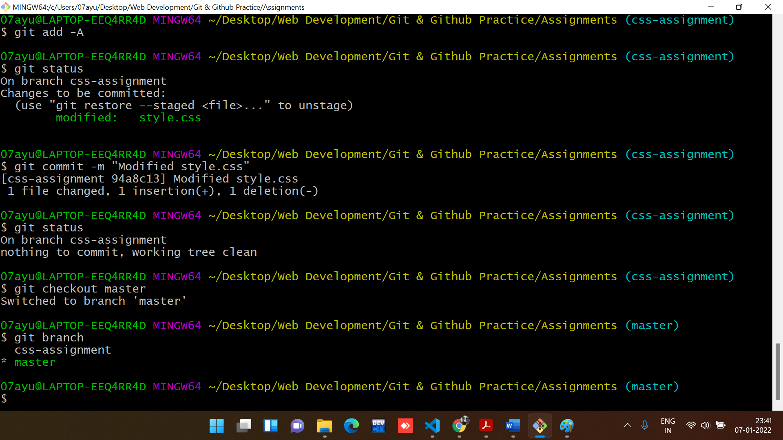

1. Merge ‘css-assignments’ branch into master. Confirm all css assignments are shown in master.

**Command used to Merge Branches:**

git merge css-assignment

**Output:**

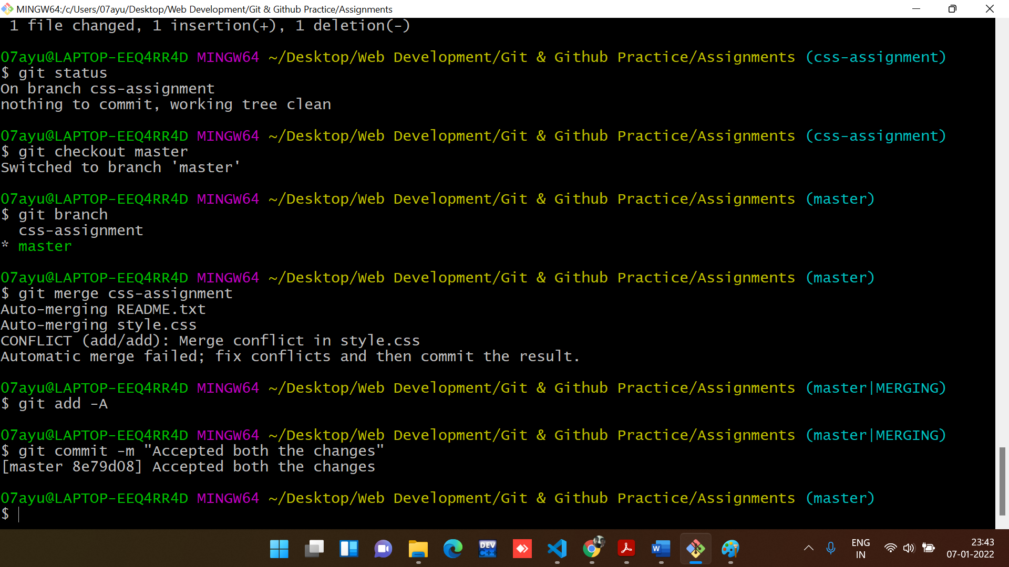

1. Finally delete the ‘css-assignments’ branch.

**Command used to Delete Branches:**

git branch -d css-assignment

**Output:**

